A matrix is an arrangement of objects, in this case LEDs, arranged in a grid of rows and columns. This is just the electrical topology, physically it can be arranged in any pattern or grid as you see fit. The point is that with a matrix arrangement we can control a lot of LEDs with just a few output pins. The number of LEDs you can control is the product of the number of columns and rows. That is, suppose you have four columns and six rows you can control 4 X 6 = 24 LEDs. The most usual arrangement is an eight by eight matrix that gives a total of 64 LEDs from 16 output pins. There are ways of reducing this requirement even further as we will see later on.

One of the main points about a matrix is that we can’t control all the LEDs at the same time. You can only turn on the LEDs that lie on one row or columns at any instant. Whether it is a row or column depends on how the matrix is wired up. What ever way round you have it you can only have one set on at a time. However, you can play a trick, by flashing each one in turn fast enough so that they appear to be on all at the same time. This is done by the persistence of vision of the eye, and if it is done fast enough it doesn't appear to be flickering.

LED Matrix

The basic idea is that both ends of the LED are under control, it is only when the anode is high and the cathode is low that the LED lights up. Here we see one LED lit (green).

If we have two columns low then two LEDs on the row light up. Note that the high line (row) has to supply (source) the current for two LEDs where as the columns only have to connect to ground (sink) only the current for one LED.

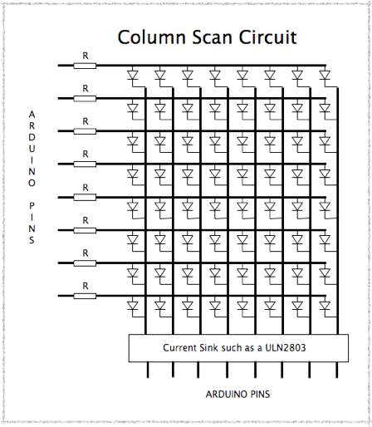

If you want to drive a matrix with an Arduino you must use an external driver for the current source or current sink. If you want to drive a matrix with an Arduino you must use an external driver for the current source or current sink.

The column sink circuit can be the ULN2803 which consists of eight Darlington  drivers conveniently in one package. The collective current that these chips can switch is about 650mA at any one time and so allows a maximum current of  650 / 8 = 80mA per LED. However in practice this is limited by the amount of current the arduino pins on the rows can source. This should be less than 40mA. Where as an LED normally takes a maximum of 20mA of continuos current the fact that any one LED is only on for one eighth of the time means you can put more current in it, this is known as the pulsed current or peak current. It is normal to overdrive the LEDs like this to compensate for the fact that as they are only on for one eighth of the time they do not appear as bright as LEDs that are on for all the time. However there are many other types of current sink circuits like simple transistors or FETs. Note that these driver circuits are inverting, that means you need a logic one to sink the current. Therefore the walking zero pattern has to be a walking one pattern

If you want to go for a Row Scan matrix then you need an external current source driver, using a circuit like this:- 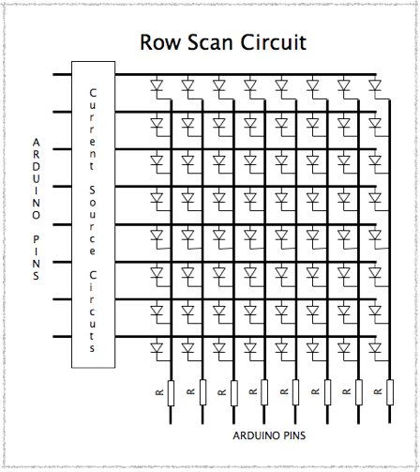

Task

You are required to build as a minimum, a 3x3x3 cube. If the student wishes, they may opt to build a 4x4x4 cube, but they will be judged the same way as for a 3x3x3 cube.

The student must assemble the cube and using the routine guide, program the Arduino chip to execute the routines. Students must be able to demonstrate the routines as outlined in the guide.

Students will be assessed in the following categories:

1. Assembly of cube – quality of assembly, soldering skills, accuracy of build, etc.
2. Circuit assembly – quality of wiring, accuracy, etc.
3. Execution of routines – is the student able to demonstrate the routines as required.
4. Programming skills – efficiency of code, use of advanced programming techniques, etc.

Students are expected to work at a level of skill and quality that reflects the expectations of a senior grade 12 student.